**The Problem Statement**

Jan's wholesale and Retail is a small grocery store in Papine. The supermarket's management is dissatisfied with the service they provide to their customers, particularly on weekends and at the end of the month when the store becomes crowded. The lines at the supermarket are extremely long because clerks must manually write up the invoices before the customer pays at the cashier. Currently, the cash register is only used to collect money for payment. It does not keep track of what is checked out so that the inventory can be updated.

The management has made the decision to computerize their system in order to improve the customer experience and reduce the lines. They expect the system to improve their internal procedures as well.

# Log In

When the program is first opened, the log in screen is shown. A staff member would use their id number to log in/clock in.

# Dashboard

The dashboard page was designed to display various system functions. The side bar, which is shown to the far left of the dashboard, contains a list of the different pages. The side bar allows the user to navigate from one page to another or vice versa. This side bar can be accessed from any page by hovering over the left side of the program. The dashboard also displays the time, the date and the currently logged in staff member’s name. The system also includes functional buttons such as Clock out, which allows employees to clock out when their shift is over and navigation to the POS page, Invoices page, and Inventory page.

# Point of Sale Screen

A POS system, also known as a point-of-sale system, is a combination of hardware, software, and payment processing services that businesses use to accept payments from customers in person or online. The POS page enables the user to search the catalog, scan barcodes, and add customers to the system. When a product item is selected from the table, the system displays its information. The user has the authority to change the quantity of the items or delete the item if they are no longer required. The point-of-sale page will display the product’s name, unit price, quantity, and total of each item. When the check-out button is pressed, the system will then generate an invoice that includes the subtotal, tax, cashier name and, if applicable, a discount as well as the customer’s name. The point-of-sale page will also allow the user to select the appropriate payment method for the customer.

# Customer Management

Utilizing the database that was created, this will keep track of customers who are apart of the membership program. The user can view a list of first and last names, dates of birth, phone numbers, email addresses, the date of the customer's membership, and when it will expire. The user has the ability to edit customer information as well as delete information. The system also allows them to easily search for the customer and access the information required. Members receive a ten percent (10%) discount off the total before tax (15%) is added.

# Inventory Management

The inventory management system is used to view the stock of specific products in the warehouse and determine when to replenish the supply from their suppliers. The system would also assist by updating product information, deleting product information, and inserting new products. The inventory management displays the product code of the items, as well as the name of the inventory items. The system also shows the brief description of the product as well as the stock. The system displays the product's unit price and allows the user to edit the information on the system; additionally, the user can delete a product. The system displays the product categories on the side that can be selected to filter the table.

# Sales Repots

Staff are able view and print reports on products in the system using the sale report. They can retrieve data on a specific product between specific time periods. This should help them analyze customer demand as well as determine whether it should be restocked or at what rate it should be restocked. First, a record must be selected. Afterwards the report icon, between the pencil and the delete buttons, must be clicked to open the report prompt.

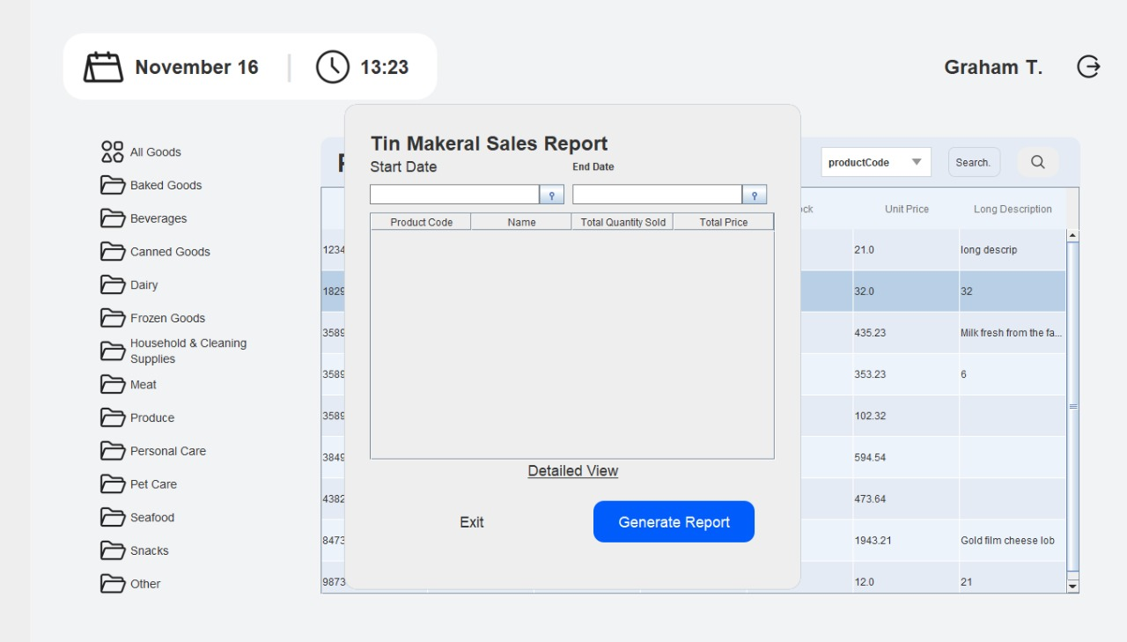

As shown above, the user is allowed to enter one start date or for a range the user would enter a start date and an end date. When the generated report button is pressed, the application will generate the data.

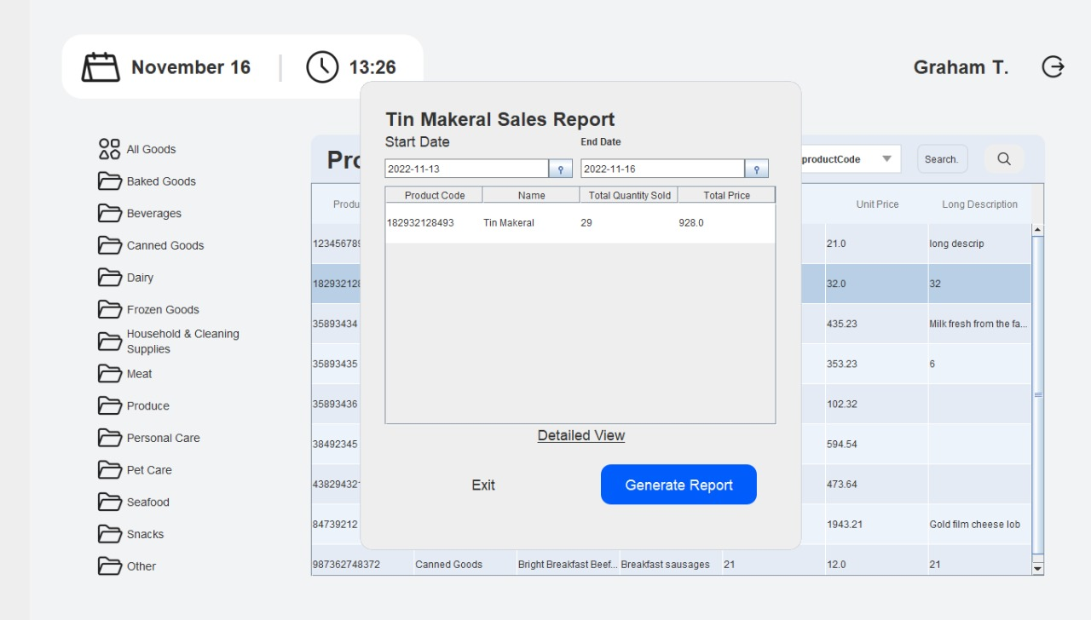

When the generate report button is selected the system shows the item’s product code, name of the item, total quantity sold in the range selected and the total sales. It also shows the user selection of date started and end date.

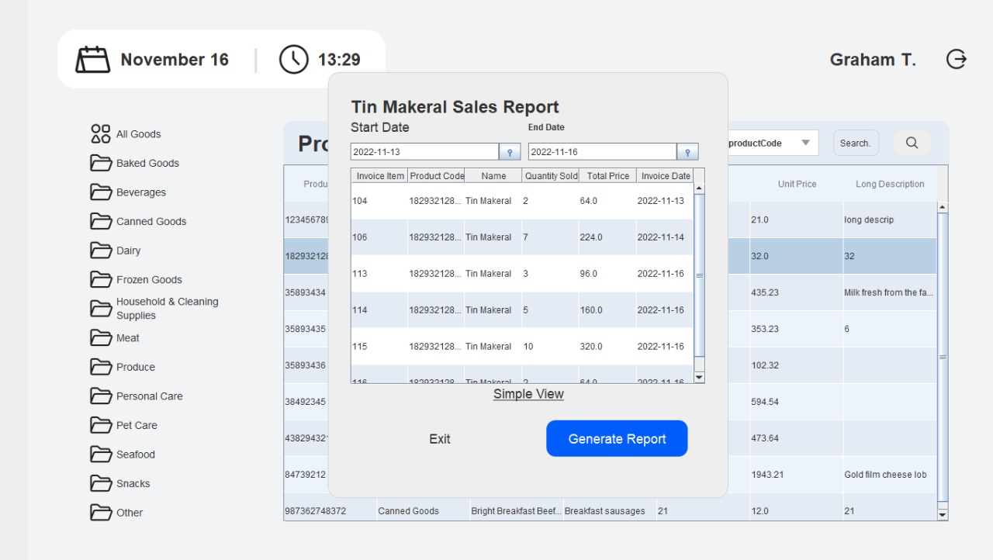

When the detailed view is selected by the user, the system generates the list of invoices that the item is a part of. It also displays the date that the invoice was created.

# Deleting a Record

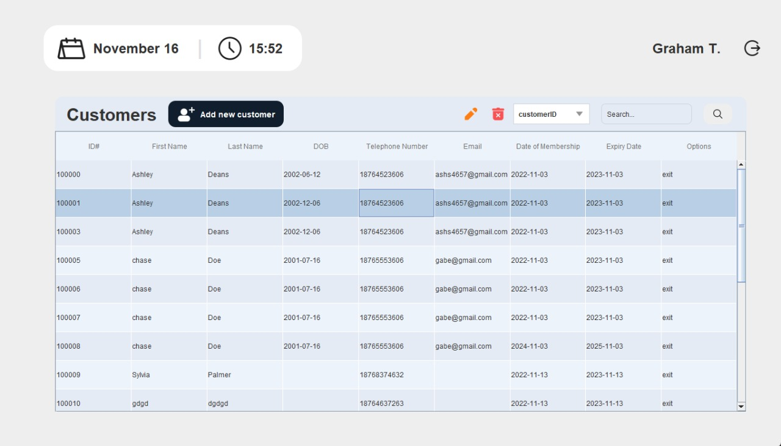

The list of customers is shown above but this operation can be done on any table(except the invoice table). First, a record must be selected. Afterwards, press the delete icon.

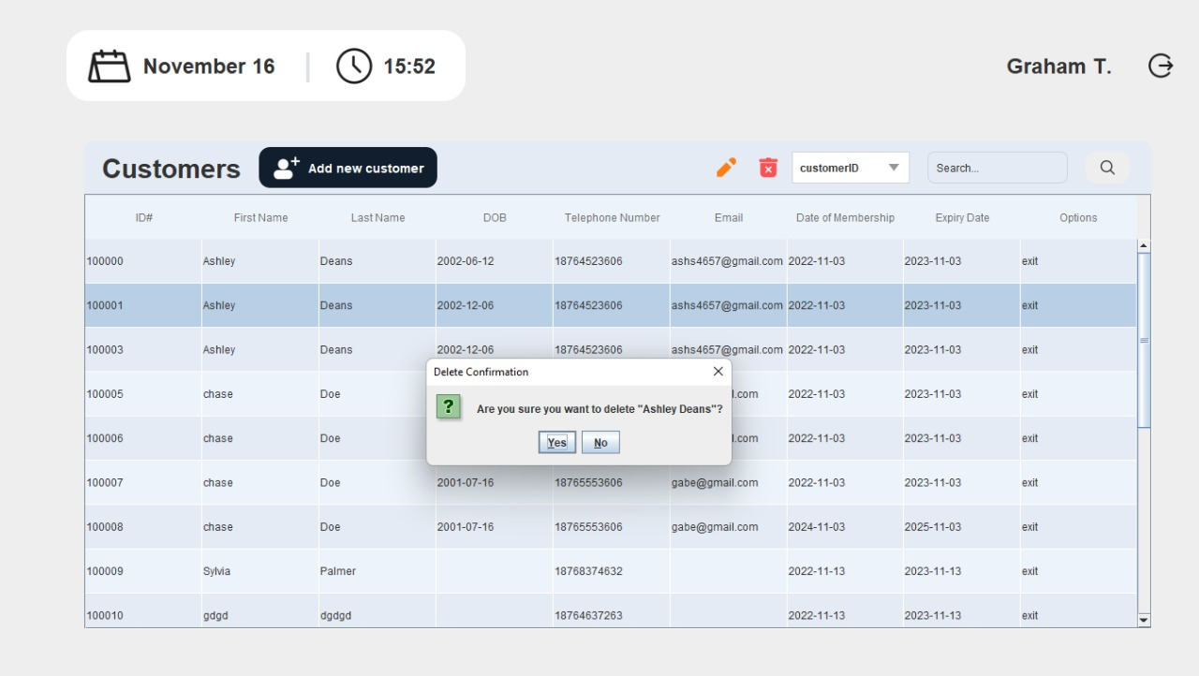

The system will then prompt the user to confirm. If yes is pressed, the record will be deleted. If the record cannot be deleted, a message will be displayed providing information as to why the operation could not be completed.

# Editing a Record

The list of products is shown above but this operation can be done on any table(except the invoice table). First, a record must be selected. Afterwards, press the pencil icon to open the editing window.

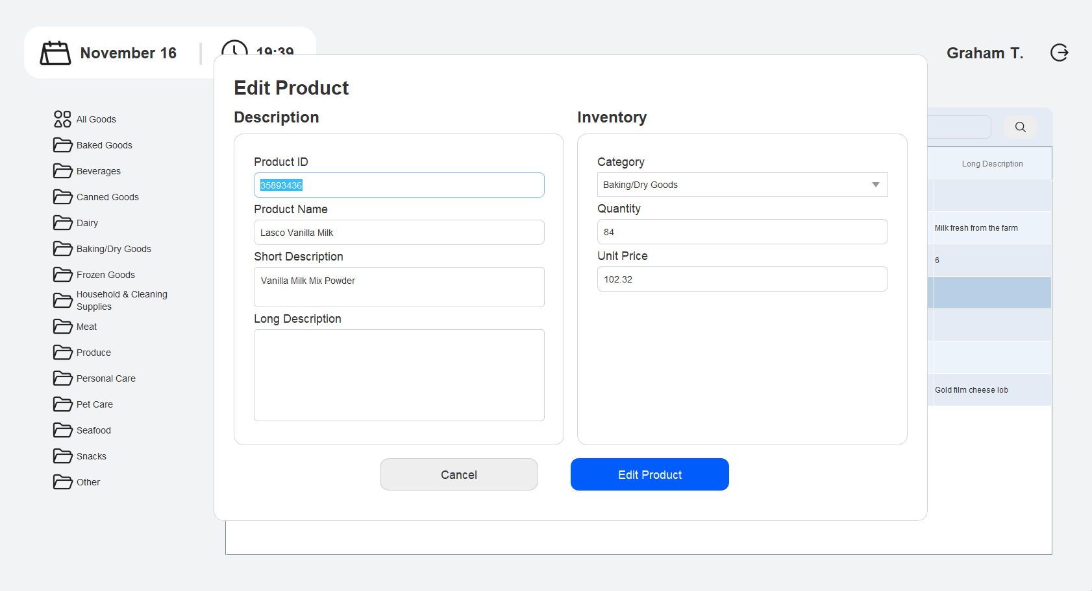  
From this screen, information can be changed in the available text fields. However, identifications numbers, such as product ID and staff ID cannot be changed here.

When you’re finished editing, the edit button should be clicked to confirm your changes.